 | The Gambia Meteorological Services  Department of Water Resources  7 Marina Parade

Monthly Climate Bulletin
N⁰ 11 April-May-June 2016

1.0 Station history of The Gambia Meteorological Network & rainfall stations

The Gambia Meteorological Services used to operate fifteen (15) Weather Observing stations covering all the regions in the country, but these were reduced to ten (10) in 2008. As of now, the department operates ten (10) Synoptic weather stations, one (1) Marine Automatic Weather Station and 25 rainfall measuring stations.

  - Part 1: Recorded Rainfall in millimetres (mm) for APRIL-MAY-JUNE 2016.

Station | R_tot | Normal_1981-2010 | R_Max | R_Max_date | R_Min |  | R_Min_date
Banjul | 15.2 | 55.9 | 15.2 |  | TR
Yundum Airport | 9.8 | 75.4 | 9.8 | 27th-June | TR | ^{27th -May}
Kerewan | 33.9 | 70.1 | 22.1 | 27th-June | 0.4 | ^{31th-May}
Sibanor | 49.6 | 73.3 | 29.8 | 30th-June | TR | ^{27th-May}
Kaur | 42.4 | 70.8 | 27.9 | 27th-June | 0.2 | ^{27th-May}
Jenoi | 82.3 | 80.7 | 72.5 | 27th-June | TR | ^{26th-May}
Sapu |  | 106.6
Janjanbureh | 47.3 | 94.8 | 15.5 | 27th-May | 1.1 | ^{31th-May}
Basse | 88.3 | 39.2 | 31.5 | 27th-June | TR | ^{19th-May}
Fatoto | 39.1 | 112.9 | 12.9 | 26th-June | 1.4 | ^{27th-May}
Bakendik |  | 48.6
Kuntair |  | 53.5
Ngain-Sanjal |  | 73.8
Kuntaur |  | 100.1
Jambanjelly |  | 52.6
Pirang |  | 58.9
Karantaba |  | 74.0
Kwinella |  | 87.4
Yalla |  | 69.4
N’jau |  | 75.5
Dankunku |  | 71.5
Gibanak |  | 65.0
Jahkunda |  | 92.3
Bansang |  | 36.0
Saresofi |  | 112.5
Mankamang | 38.1 | 92.5 | 15.2 | 25th-june | 2.5 |  | 30th-may
Girobakunda |  | 100.9
Jali |  | 45.8
Kanjibat |  | 107.6
Serrekunda |  | 49.3
Sutukoba |  | 83.4
Naude |  | 97.6

Figure 1.2: Rainfall distribution

Figure 1 indicates highest rainfall amount of 88.3 millimetres (mm) for April-May-June at Basse . The highest rainfall observed in a day was 72.5 mm and recorded at Jenoi at the Lower River Region, whilst the lowest value recorded in a day is 1.1mm and prevailed at Janjanbureh .From the table 1.2 the lowest value of 9.8 mm for the 3 months was experienced over Yundum. The country average seasonal rainfall during April-may-June stood at 40.7mm 53% above the long term mean (26.6) of 1981-2010 and a surplus of 14.1mm.

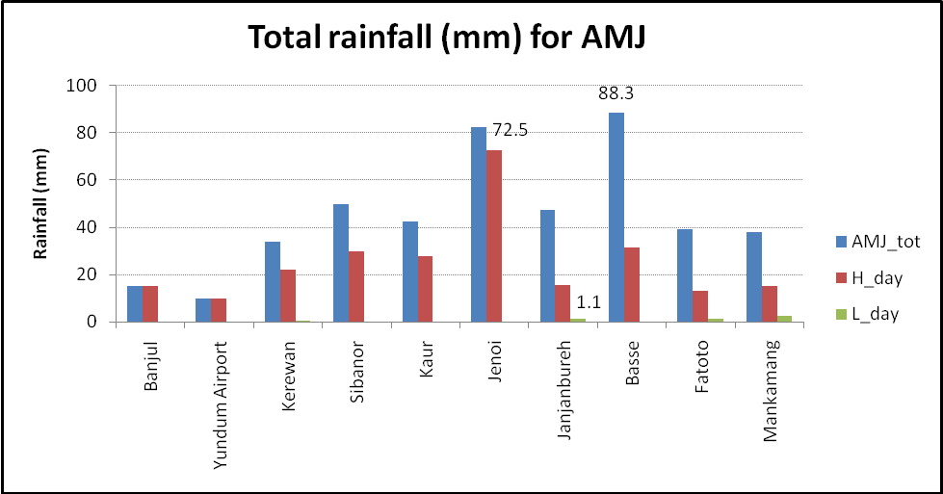

Figure 1: Rainfall(mm) for AMJ 2016

1.3 Part II : Temperature in degrees Celsius (0C) for April, May,June2016
Station _codes |  |  | MeanT-2016 | Normal  1981-2010 | MeanTmax-  2016 | Normal  Tmax | MeanTmin-2016 | Normal  Tmin | Ab Tmax-2016 | Normal  Ab max T | Ab T min-2016 | Normal  Ab T min
WMO | National | Name
61711 | 15003000 | Banjul Halfdie/Marina | 25.8 | 28.0 | 32.6 | 31.1 | 18.9 | 22.0 | 39.9 | 31.6 | 21.5 | 20.7
61731 | 15001200 | Basse | 32.2 | 27.1 | 39.8 | 39.4 | 25.5 | 24.9 | 43.8 | 41.0 | 27.4 | 23.9
61733 | 15006600 | Fatoto disp./met. | 32.4 | 27.2 | 41.4 | 39.8 | 23.2 | 24.3 | 44.0 | 41.4 | 25.3 | 23.3
61721 | 15003900 | Georgetown | 31.4 | 27.1 | 39.9 | 39.2 | 22.7 | 23.7 | 42.7 | 40.5 | 25.7 | 22.1
61707 | 15004900 | Jenoi | 29.8 | 26.8 | 38.6 | 38.6 | 20.5 | 22.4 | 43.2 | 39.9 | 23.7 | 22.1
61717 | 15000600 | Kaur | 31.1 | 27.6 | 39.5 | 39.1 | 22.7 | 23.0 | 42.7 | 40.3 | 25.4 | 20.8
61712 | 15003300 | Kerewan | 27.5 | 27.3 | 38.0 | 37.6 | 17.0 | 21.7 | 43.9 | 38.5 | 20.0 | 20.0
61722 | 15006200 | Sapu | 30.8 | 26.6 | 38.7 | 39.1 | 23.0 | 23.4 | 43.7 | 40.1 | 25.5 | 21.7
61705 | 15005900 | Sibanor | 27.8 | 26.6 | 36.8 | 37.2 | 18.7 | 21.6 | 40.1 | 38.9 | 22.5 | 19.6
61701 | 15005400 | Yundum Airport | 26.7 | 26.7 | 33.2 | 33.0 | 20.2 | 21.5 | 39.7 | 33.4 | 23.7 | 19.7

  - Part III: Relative Humidity in percentage (%) and Wind in metres per second (m/s) for
April , May, June 2016.
Station Codes |  |  | Relative Humidity (%) |  |  |  | Windspeed (m/s)_2016
WMO | National | Name | MeanRH_2016 | 1981-2010 | MaxRH_2016 | MinRH_2016 | Mean | Highest
61711 | 15003000 | Banjul Halfdie/Marina | 71 | 63 | 88 | 27 | 7.2 | 10
61731 | 15001200 | Basse | 58 | 64 | 89 | 13 | 4.6 | 16
61733 | 15006600 | Fatoto disp./met. | 45 | 57 | 81 | 16 | 6.9 | 15
61721 | 15003900 | Georgetown | 54 | 60 | 89 | 13 | 3.5 | 23
61707 | 15004900 | Jenoi | 70 | 57 | 92 | 20 | 5.3 | 12
61717 | 15000600 | Kaur | 51 | 52 | 86 | 12 | 7.0 | 16
61712 | 15003300 | Kerewan | 63 | 59 | 90 | 16 | 7.0 | 12
61722 | 15006200 | Sapu | 47 | 58 | 85 | 8 | 6.0 | 17
61705 | 15005900 | Sibanor | 61 | 63 | 97 | 22 | 6.5 | 15
61701 | 15005400 | Yundum Airport | 77 | 70 | 93 | 24 | 7.3 | 16

1.5 Part IV: Sunshine (hours) and Evaporation (mm) for April, May, June 2016.

Station_codes |  |  | Sunshine 2016 |  |  |  | Evaporation Class A (mm) 2016
WMO | National | Name | Total | Normal_1981-2010 | Max | Min | Total | Mean
61711 | 15003000 | Banjul Halfdie/Marina | * | * | * | * | * | *
61731 | 15001200 | Basse | 284.2 | 192.2 | 11.0 | 4.5 | 261.2 | 8.6
61733 | 16006600 | Fatoto disp/met. | 252.7 | 86.7 | 11.0 | 5.6 | 261.9 | 8.6
61721 | 15003900 | Georgetown | 285.4 | 147.1 | 12.0 | 5.9 | 208.4 | 6.8
61707 | 15004900 | Jenoi | 210.5 | 181.5 | 11.0 | 4.3 | 246.8 | 8.1
61717 | 15000600 | Kaur | 241.2 | 99.7 | 11.0 | 4.5 | 276.1 | 9.1
61712 | 15003300 | Kerewan | 262.8 | 201.8 | 11.0 | 4.6 | * | *
61722 | 16006200 | Sapu | 242.2 | 125.9 | 11.0 | 7.3 | 256.9 | 8.4
61705 | 15005900 | Sibanor | 247.8 | 116.5 | 11.0 | 1.8 | 147.8 | 4.9
61701 | 15005400 | Yundum Airport | 274.8 | 218.5 | 11.0 | 4.5 | 171.0 | 6.2

2.0 Part V: Climate Report explanations

PREFACE
Selected climatological data of general importance from weather stations in The Gambia has been compiled in this report. Blank spaces indicate either missing or delayed records. If data are missing for one day or several days for one station within the selected period, the station concern it is marked with an as terix (*). Observed values (OBS) and the normals (NORM) of these data values from the long period averages are given for the following elements:
- Average air temperature
- Rainfall
- Relative Humidity
- Sunshine
- Interpolated map for rainfall is included.

EXPLANATION OF TABLES

- Rainfall (mm) amount is measured every six hours using a standard rain gauge placed 80cm above ground level. The Total rainfall amount for any given day is the cumulative or accumulated six hourly rainfall amounts. A Rainy day is defined as a day with a total rainfall amount equal or more than 1mm.
- Air Temperature (°C) observations are made from thermometers exposed in Stevenson Screens, 1.25 metres above the ground. The Maximum and Minimum Temperature (°C) observed/ obtained, indicates the highest and lowest temperatures during the specified period.
- Relative Humidity is derived from the readings of the dry and wet bulb thermometers and expressed in Percentage (%).
- Sunshine Duration is measured using a Campbell-Stokes Tropical Sunshine Recorder and is recorded in hours.
- Actual Evaporation is determined from a Class A Pan and measured in millimetres (mm).
- Wind speed is read from a Cup Counter Anemometer mounted 10 metres above the ground and read in knots. It can also be converted to metres per second (m/s) or kilometre per hour (km/h).

Abbreviations:
- MeanT : Mean Temperature
- Mean Tmax : Mean Maximum Temperature
- Mean Tmin : Mean Minimum Temperature
- Highest M T: Highest Maximum Temperature
- Lowest M T: Lowest Minimum Temperature
- AMJ_tot: Total for April-May-June
- H_day: Highest observed in a day
- L_day: Highest observed in a day

Published by: Climate Unit
Department of Water Resources
7 Marina Parade
Banjul, The Gambia
Telephone: 00 (220) 422-7631/4222-872/422-4122
Fax: 00 (220) 422-5009
http://www.mofwrnam.gov.gm
E-mail: info@mofwrnam.gov.gm; infoclimate@gmail.com

