
No: 26. 2014/15 Cropping Season Review for May 21-31, 2015 and Outlook for June 1-10, 2015

HIGHLIGHT
- During May 21-31, 2015, masika rains continued to feature over some of the bimodal areas whereas the unimodal areas experienced mostly dry conditions.
- The expected rainfall over the bimodal areas during June 1-10, 2015 may be favorable for development of late grown maize crop but farmers are advised to seek professional advice from nearby Agricultural and livestock extension officers.
- Farmers are also advised to take precautionary measures for their safety and properties where thunderstorms are predicted.

SYNOPTIC SUMMARY DURING

MAY 21-31, 2015

D uring May 21-31, 2015, the northern hemisphere high pressure systems (Azores and Siberia) relaxed significantly whereas the southern hemisphere high pressure systems (St. Helena and Mascarene) continued to intensify. Over land, the East Africa Ridge dominated over the south-western and central parts of Tanzania hinterlands. As for Sea Surface Temperatures (SSTs), warm SSTs dominated the Western Indian Ocean closer to East African coast extending to central Indian Ocean and over Atlantic Ocean near Angola coast whereas neutral to slightly warm SSTs were observed over the north-western Indian Ocean closer to Somali coast and over the Eastern Indian Ocean. This configuration made the Meridional arm of the Inter-Tropical Convergence Zone (ITCZ) to stay over Congo basin while the zonal arm of the ITCZ on the other hand, moved north-wards into the northern hemisphere, reducing the influence of the ITCZ rainfall to the southern, south-western, western and central parts of the country, with occasional rains over coast strip of the country.

WEATHER SUMMARY DURING

MAY 21-31, 2015

With the observed synoptic conditions during May 21-31, 2015, seasonal rains (masika) continued to feature over some of the bimodal areas especially north-eastern highlands and Lake Victoria Basin. However, parts of those areas and much of the northern coast experienced dry conditions. The unimodal areas on the other hand experienced mostly dry conditions with exception of few areas (including southern Morogoro region) where rainfall was observed as shown in Figure 1 which is Satellite Rainfall Estimates merged with gauge data from Tanzania rainfall stations network showing total rainfall distribution during the dekad. Figure 2 also shows rainfall performance during the dekad as percentage of long term average whereby the observed rainfall over the bimodal areas during the dekad was above normal to normal except some parts of northern coast and Lake Victoria basin that received below normal rainfall. Over the unimodal areas, the observed rainfall was mainly normal to below normal with some areas (mostly parts of Dodoma, Tabora, Iringa and southern Morogoro regions) receiving above normal rainfall.
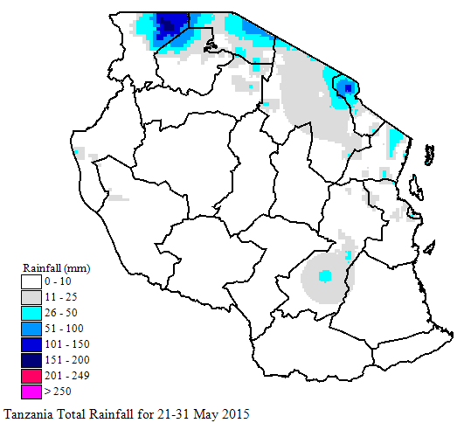
Figure 1: Spatial total rainfall distribution (mm) during May 21-31, 2015

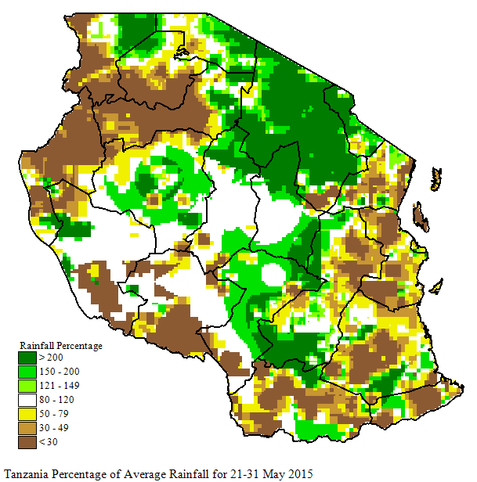
Figure 2: Rainfall performance during May 21-31, 2015 as percentage of long term average.

AGROMETEOROLOGICAL SUMMARY DURING MAY 21-31, 2015

During May 21-31, 2015, the observed rainfall was reported to have been favourable for crops development over much of the bimodal areas where maize crop was at various development stages. In Mara and Kilimanjaro regions, maize crop was mostly between tasseling and flowering stages whereas in many places of Mwanza, Arusha, Tanga, Coast and Morogoro regions, the crop was between flowering and waxy ripeness stages. The crop was reported in good condition in all these areas. Over the unimodal areas, maize crop is at full ripeness stage and harvesting has started in some places including central areas.

HYDROLOGICAL CONDITIONS

DURING MAY 21-31, 2015

Water levels in dams and river flow discharges were moderate across the country.

ENVIRONMENTAL CONDITIONS DURING

MAY 21-31, 2015

During May 21-31, 2015 moderate to cool temperature conditions prevailed across the country except over south-western highlands where relatively cooler temperature conditions prevailed.

EXPECTED SYNOPTIC CONDITIONS DURING JUNE 1-10, 2015

During June 1-10, 2015, high pressure systems in the northern hemisphere are expected to continue relaxing while their counterparts in the southern hemisphere are expected to continue intensifying. With this configuration, the ITCZ is expected to continue moving northwards from its current position. This shifting is expected to influence weather over the bimodal areas of the country such that masika rains are expected to recede during the dekad. Warm SSTs are expected to be observed over Somali coast in the West Indian Ocean, Central Indian Ocean and in the Atlantic Ocean closer to Angola coast where as neutral to slightly warm SSTs are expected over the East Africa coast. Low level wind speed is expected to start rising over some parts of the country and the wind is expected to be characterized by southerly flow over the eastern sector, turning to south-easterly over remaining parts of the country. Over most parts of uni-modal areas, nights over land are expected to be dominated by clear sky and slightly cool temperatures.

EXPECTED WEATHER DURING

JUNE 1-10, 2015

Lake Victoria Basin (Kagera, Mwanza, Mara, Geita, Simiyu and Shinyanga regions): thunderstorm and rain showers over few areas are expected. North-eastern highlands (Kilimanjaro, Arusha and Manyara regions): rain showers over few areas are expected. Northern coast (Dar es Salaam, Morogoro and Tanga regions, the isles of Unguja and Pemba): occasional periods rain showers over few areas are expected. Western regions (Kigoma and Tabora regions), Central areas (Dodoma and Singida regions), South-western highlands (Rukwa, Iringa and Mbeya regions), Southern Coast (Mtwara and Lindi regions) and Southern region (Ruvuma region): Mainly dry conditions with occasional periods of rain showers and thunderstorms over few areas are expected.

AGROMETEOROLOGICAL OUTLOOK AND ADVISORY DURING JUNE 1-10, 2015

During June 1-10, 2015, the expected rainfall over the bimodal areas may be favorable for development of late grown maize crop but farmers are advised to seek professional advice from nearby Agricultural and livestock extension officers. Farmers are also advised to take precautionary measures for their safety and properties where thunderstorms are predicted.

HYDROLOGICAL OUTLOOK DURING JUNE

1-10, 2015

Prepared by
TANZANIA METEOROLOGICAL AGENCY
3rd, 4th& 10 ^{th} Floors - Ubungo Plaza – Morogoro Road.
P.O. Box 3056 Tel. 255 -(0) 22 – 2460706-8 ; Fax: 255 - (0) 22 – 2460718 E-mail: (1) met@meteo.go.tz (2) agromet1_tz@meteo.go.tz
Dar es Salaam UNITED REPUBLIC OF TANZANIA

During May 21-31, 2015, water levels in dams and river flow discharges are expected to remain moderate over the bimodal areas but slight decrease is expected over the unimodal areas of the country.

